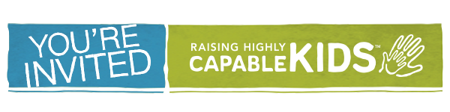
(Organization/Community) Vision Casting Event
Date/Time
Location
Address

Raising Highly Capable Kids is an 13 week, evidence-based, multi-lingual (English, Spanish, Arabic and Chinese) parenting program developed to build stronger families by empowering parents with the confidence, tools, and skills they need to raise healthy, caring, and responsible children. Based on the Search Institute’s 40 Developmental Assets, the program has been proven to increase parent engagement, childhood resilience and school achievement. This Vision Casting Event is designed to promote a community wide collaboration and offer an in-depth overview of the Raising Highly Capable Kids program, establish next steps, and navigate questions specific to a successful launch in (city) and surrounding communities. Please RSVP to (Name/Email).
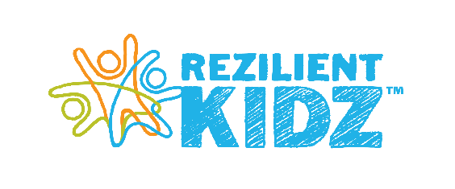
To learn more and view inspirational videos, go to www.capablekids.com.

Raising Highly Capable Kids is one of the programs available through RezilientKidz. RezilientKidz is a 501(c)(3) established to partner with community leaders who are invested in supporting families with tools to support parents, marriages, and families. RezilientKidz is located in Colorado Springs, CO.

